Portable massage table
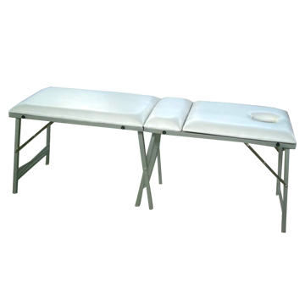

Content:
1 massage table with adjustable backrest,face hole and a plug
1 manual

Assembly instructions:
No tools are required to assemble the massage table

- Unfold the table
- Unfold the legs
- The massage table is now ready for use

