Electric Massage Table
OPERATING MANUAL

Model No.ET02 — Electric Massage Table

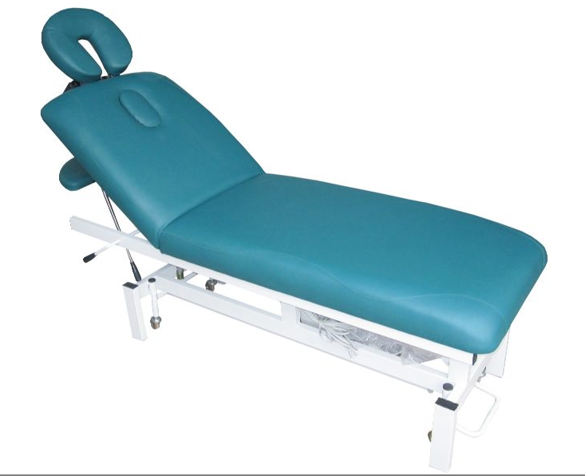

FOREWORD
This manual has been prepared for the owners of the H-ROOT powerlift range of tables.
It contains general information on how to operate, maintain and care for your powerlift equipment.
Reading and understanding this manual thoroughly will not only maximize the life and efficiency of your H-ROOT Electric table, it will also aid in its safe operation.

SAFETY INSTRUCTIONS

- Read the following very carefully and ensure that all staff members / personnel who operate the Table
are fully briefed on safety compliance.
- Do not place your hands or feet anywhere near the moving parts of the Table when raising or lowering.
- Use both hands to adjust the angle or the level of any section.
- Do not change the section angle when a client’s weight is on it.

INSTALLATION

- Inspect the wrapping carefully when receiving the Table and if there are signs of damage, you must contact your transporter immediately.
- Do not sign for any goods that appear damaged or tampered with.
- No assembly is needed on any H-ROOT Electric Tables.
- When the table is unpacked from the box both the power cable and foot pedal will need to be united, and then plugged into the wall.

UNPACKING INSTRUCTIONS:

- Do not use sharp objects or a knife when unpacking to avoid damage to the upholstery or paint.
- Lift off carton lid carefully and either lift table (4 person job) out of carton. Otherwise, carefully cut the end of the carton and slide table out. Make sure that the wheels are not locked when you do this.
- Check the voltage rating on the serial plate of the motor. The plug of the motor should only be inserted
into 110V or 220V power outlet as indicated on the serial plate.

OPERATING INSTRUCTIONS

Powerlift Operation:
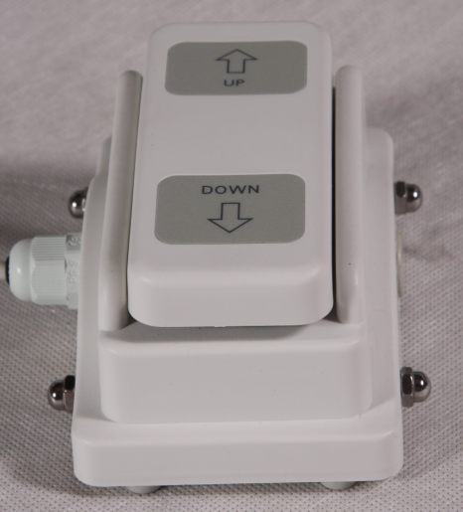
With single motor tables one foot pedal is supplied. The pedal depresses when pressure
is applied. Use your foot to apply pressure on the end corresponding to the direction in which you would like the table to go.
Take care not to run over the foot pedal cable when moving the table.
Avoid jerking the foot pedal cable.
WARNING: Do not hold foot pedal down after motor has reached its maximum
or minimum point. This may damage the motor and frame and will not be covered by warranty.

Manual Head Section Adjustment: 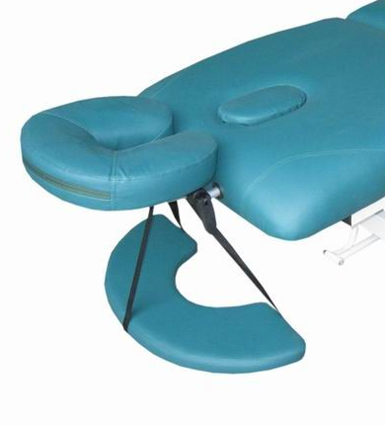
Support the section to be adjusted with one hand and turn the lock
release handle towards the centre of the table to raise a section.
Keep pressure on the lock release handle until you have manually adjusted the section to the desired height or angle and then release to automatically lock into place.
To lower a manually adjusted section follow the directions above but
turn the lock release handle towards the end of the table.

Locking The Wheels
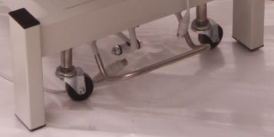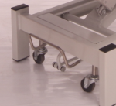
“Mobility State” “Stationary State”

All Tables are available with our streamline base - foot release caster system
- To get mobility: place your foot on the positioning lever and push downward.
- To get stationary: lift positioning lever up with your foot.

NOTE: DO NOT USE CASTER SYSTEM DURING TREATMENT / THERAPY OR FOR PATIENT TRANSPORT.
THE MOBILE OPTION IS ONLY FOR TABLE TRANSPORT ITSELF.

MAINTENANCE

Electrically powered Tables are equipped with a longwearing, maintenance-free electric motor. Should any problems occur with this unit, please contact us or the motor company for instructions.
To ensure continuous trouble-free operation, the pivot joints and sliding surfaces on the table should be cleaned and lubricated on a regular basis. The recommended lubricant is Helmar H4000 silicone spray; although any good quality silicone spray lubricant will suffice (food grade is preferable to reduce residual odour and staining). These products can be purchased at your local hardware store.
Lubrication intervals should be from 10-12 weeks depending on use.

VINYL CARE

The vinyl upholstery requires cleaning with warm soapy water to remove skin oil from surfaces, especially around the areas where the face, back or chest come into contact with vinyl. Cleaning intervals should be once per day depending on use.

Note: Do not use alcohol or aromatic solvents to clean upholstery. These may cause damage to the vinyl which is not covered under warranty.

Treatment of specific stains
Always remember:
- Prompt attention yields more complete removal.
- Wipe stains from ‘outside in’ to avoid spreading.

Lipstick, shoe polishes, fatty & greasy stains:
Remove as much of the stain as possible without rubbing the stain into the vinyl. Wipe over with methylated spirits. Wash with warm soapy water and dry with clean cloth.

Chewing gum:
Set the gum hard with an ice cube. Then scrape over with the blunt edge of a knife. Wipe over with methylated spirits and then finish by wiping with warm soapy water.

Pen ink:
Wiping with methylated spirits is sometimes effective if stain is fresh.

Important
Never use furniture polishes, abrasive cleaners, steel wool or cleaners containing solvents as these products can cause damage to the vinyl surface.

TROUBLE SHOOTING
PROBLEM: MOTOR DOES NOT OPERATE
Possible solution:
- Make sure that the motor is receiving electrical power.
- Plug another appliance into the wall power socket to ensure that it is operating correctly or try plugging the table into another wall socket that is known to be working.
- Check power plug to see if it is securely plugged into the electric outlet and the cord is not severed or damaged.
- Ensure that the plugs of all leads connected to the motor control box are pushed firmly into their sockets
- If you have two foot pedals or another table, try swapping the foot pedals over.

PROBLEM: MOTOR OPERATES - BUT MAKES AN UNUSUAL NOISE
Possible solutions:
- Clean and lubricate the motor pivot points as described in the maintenance section of this manual.
PROBLEM: MOTOR OPERATES - IN ONE DIRECTION ONLY
Possible solutions:
- Clean and lubricate the motor pivot points as described in the maintenance section of this manual.
- Ensure that the plugs of all leads connected to the motor control box are pushed firmly into their sockets.
PROBLEM: END SECTION SLIPS ON ONE OR BOTH SLIDES WHEN WEIGHT IS APPLIED.
Possible solutions:
- Clean lock bars and white lock tabs with alcohol wipes or a rag dipped in methylated spirits.
- Rub length of lock bars with a light grade of a sandpaper.
- Ensure the mounting screws on the white plastic lock tags and the table mounting backs are fully tightened.
- Ensure the table end of the lock bars are seated properly into the plastic mounting blocks on the underside of the table, if not it is necessary to tap them gently into place with a hammer.
- The end of the bar should be flush with the edge of the plastic mounting block and not protruding or recessed.
PROBLEM: REMOVEABLE FACE CREST BAR SLIPS OR IS LOOSE.

Possible solutions:
- Hold the locking nut opposite the locking bar and turn the locking bar a half-turn clockwise to tighten. Check tightness of face crest bar and repeat if necessary. To loosen the lock bar - turn anticlockwise.
- Tighten the screws on the mounting brackets under the tables.
- If the above has been completed & the problem is not resolved call …………..for service.

