Instruction
Model No.:Y008
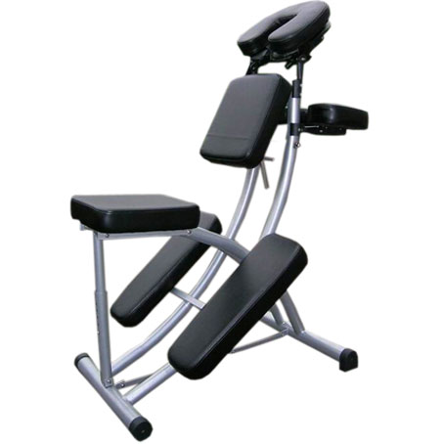

Content:
1 massage chair with adjustable backrest,headrest,armsupport
1 manual
1 Carryiing bag
Assembly instructions:
No tools are required to assemble the massage chair

- Open the carton and take out the chair
- Unfold the chair
- Unfold the legs
- Put the headrest into the holes on the top of the chair
- The massage chair is now ready for use
- If you want to move the chair,use the carrying bag
------------------------------End-------------------------------------------------

