Instruction for
3-section portable massage table
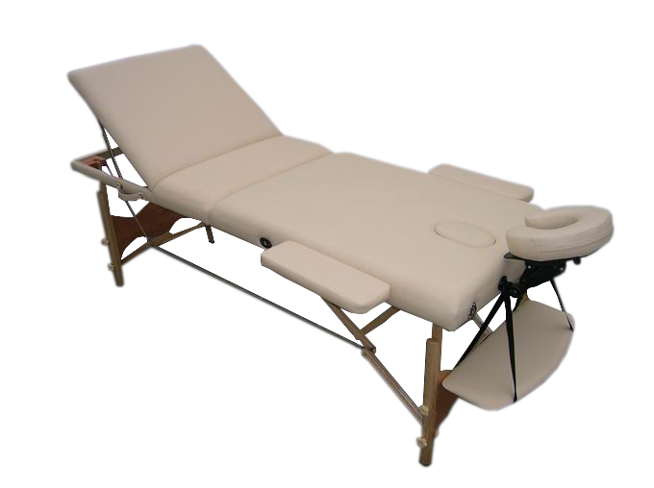Model No：M012A
Congratulations on the purchase of your new portable massage table. Your new table has been skillfully crafted to exacting standards, utilizing high quality components and materials. with proper use and care, as outlined in this user’s guide, your table should years of reliable performance. To insure the safe and correct use of your table, please take a moment to read this entire guide prior to using your table .

PRECAUTIONARY INSTRUCTIONS
- Maintain the table periodically. Make sure all items are secure and the cable has not deteriorated or frayed. Make sure there are no cracks in the wood structure.
- Do not overload the table beyond the recommended weight limit. This could result in serious injury to the user.
- Do not use alcohol based cleaners when cleaning the vinyl. This will cause damage to the vinyl material. Use warm soapy water and wipe dry.
- Make sure when using the table that all four legs are on a solid even surface and at the same level.
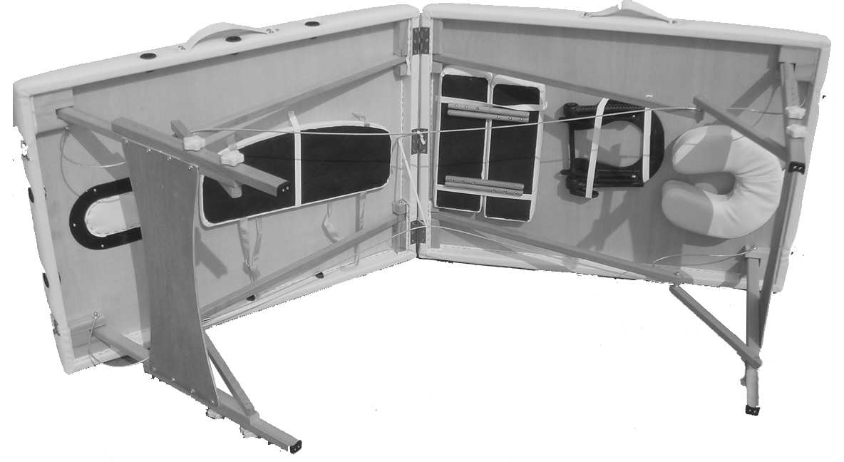
Table set up
Place the table on its side ,
release the buckles,
partially open the table ,
and remove the accessories figure 1.
Figure 1

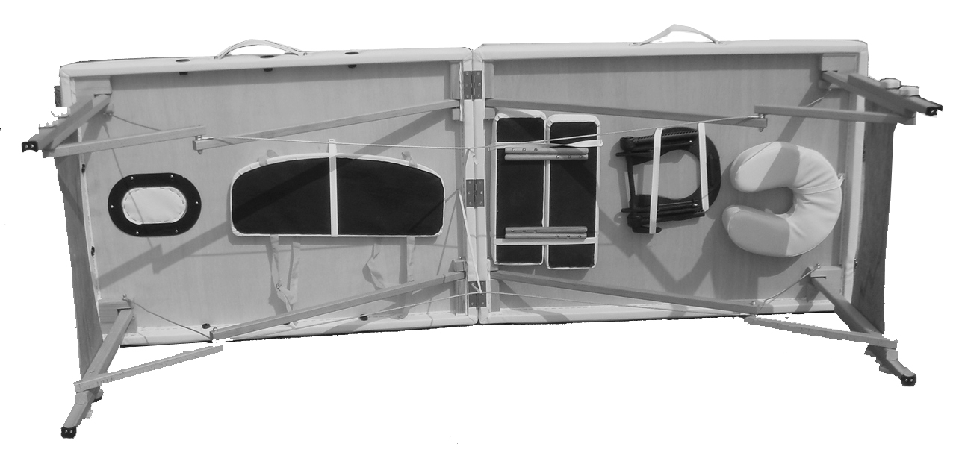
Standing behind the table ,
grasp both table handles and gently
swing in an outward motion to fully open
the table. The legs should open
automatically figure 2.

Figure 2
Turn the table upright by lifting the middle of the table. Press down in the middle of the table to make sure the table lays flat. If the table peaks in the middle , check and straighten out the cables.

Table and the accessories use
We provide optional accessories for you. Please read instruction carefully before use.

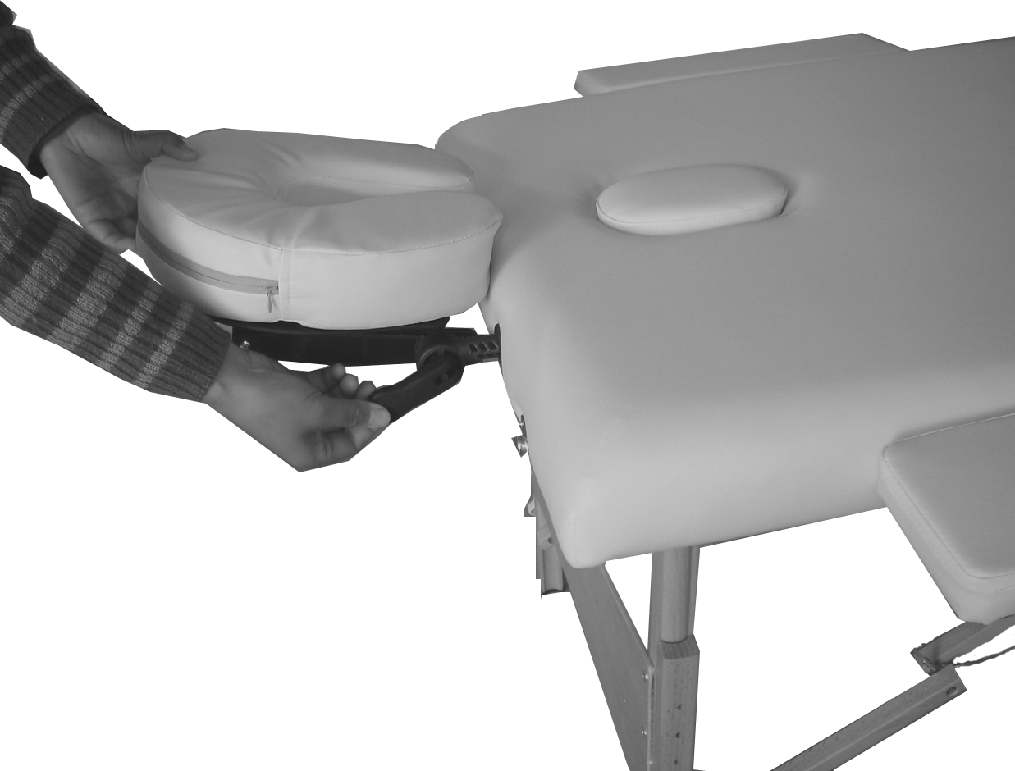
Headrest:
The headrest consists of a crescent headrest base
and a crescent face pad. It will give your
client comfortable head and face support.
You may have a different option for the headrest
base, the adjustable headrest is ease for you to
change the angle and height of the base by
adjusting the base handle figure 3. Figure 3

Adjustable armrest shelf:
This adjustable armrest shelf is a good device
support your client’s arms at the front of the table. Hang the
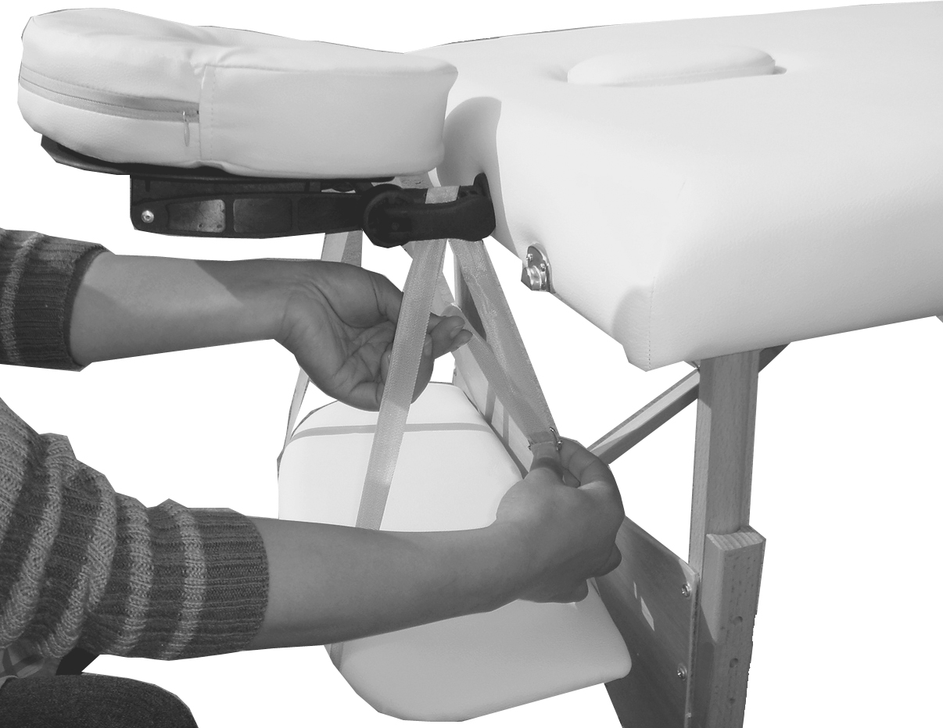
armrest shelf on the two bars of the headrest and slide the
belt up or down for the optimum position figure 4.

Figure 4
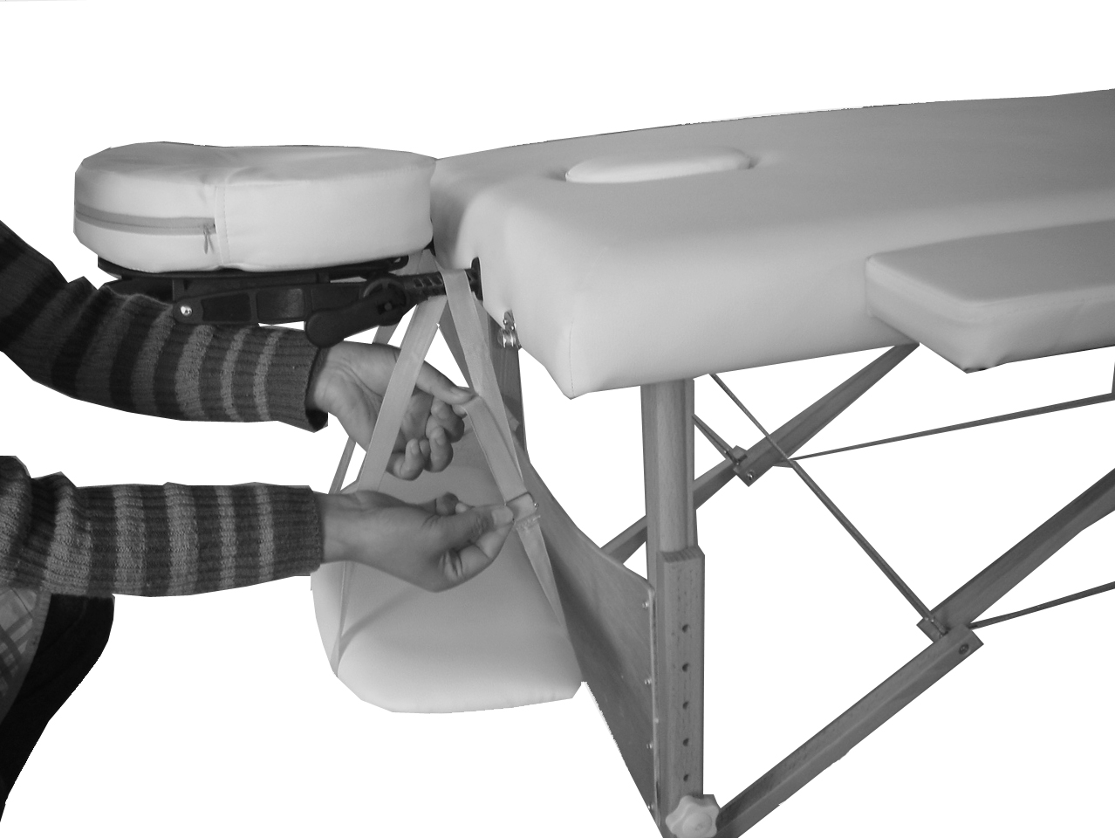
Arm sling:
This is an alternative armrest accessory with the
same function of the armrest shelf. Please
refer to the usage notes of the armrest shelf
figure 5. to the right.
Figure 5

Side arm extension:
This is the side arm extensions option for our table. These removable padded side armrests add the table width. They fit into the required accessory holes in each side of the table, will give a comfortable arm support especially for larger clients.

Height adjustment:
The proper table height is determined by the therapist’s height, modality, and technique. You can adjust the height by removing the grip knob from each leg. Replace the knobs after adjusting each leg to the desired position.

Table weight limits:
Positioning the client in the center of the table will help distribute the weight evenly and insure stability. Gently sit near (not on ) the center of the table at first, then sit as close to the center (from the edge) as possible, the working weight is the combined weight of the client and the maximum amount of downward pressure being applied by the therapist, for example :for a client weighing 300 pounds, the maximum working weight for the table is 500 pounds, the maximum downward pressure that can safely be applied is 200 pounds, as pressure applied at sideward angle puts considerably more stress on a table, the maximum sideward pressure should not exceed 50% of the maximum downward pressure.
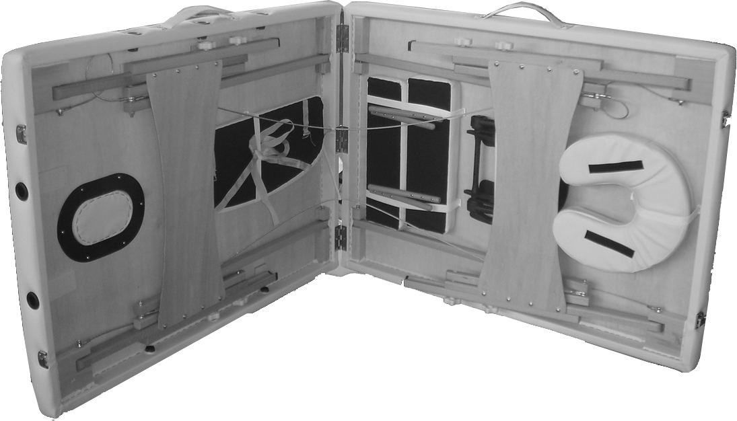
DO NOT EXCEED REFERRED MAXIMUM WORKING WEIGHT (Never Exceed The Load Limits Of The Table;
Doing So May Result In Serious Injury And/Or Damage)
Storage:
Attach headrest base and face pad onto the elastic
under the table as shown, place every
accessory in their original position figure 6.
The carry case should be used when transporting or Figure 6
storing the table, to help protect the table from damage, when not in use, store the table in a cool dry place, and away from direct sunlight. Do not expose the table to extreme (hot or cold) temperatures, or moisture.

Table care
Upholstery care
Daily cleaning: remove daily dirt and grime from the table with a mild soap and warm water solution , and dry with a soft lint-free cloth.
Disinfecting: Disinfect the table as required, with an isoprppanol based hospital grade disinfectant cleaner(approved for use on polyurethane vinyl).
Stain removal: some minor stains can be removed with a mild non-abrasive cleaner. Spray a damp cloth with cleaners and gently wipe to remove stain, rinse thoroughly with warm water, and dry with a soft lint-free cloth. More stubborn stains may require professional cleaning.
Note: never use harsh or abrasive cleaners or chemicals to clean the table. Doing so may damage the upholstery. Avoid using any protectants, as they may harm the vinyl.
Wood care:
Your massage table is made of select hardwoods and is finished with lacquer that requires no special care. If desired, you may polish occasionally with a quality wood care product. Keep the table dry, and avoid exposure to wet or humid environments. Should the table get wet, quickly and thoroughly dry with a soft cloth.

